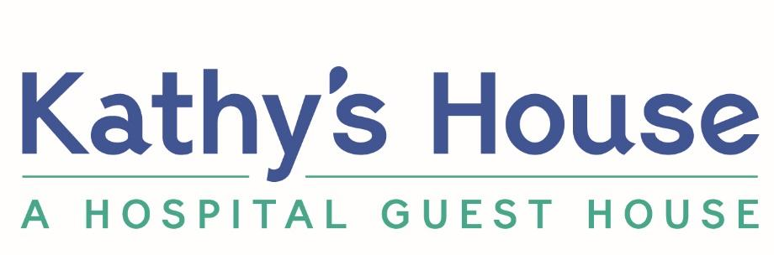

Yes, I/we would like to make a pledge commitment to Kathy’s House!

Name: ________________________________________________________________________________
Address: ______________________________________________________________________________________

Phone: _______________________________________________________________________________________

Email: ________________________________________________________________________________________

Gift Options (select as many as apply):
Kathy’s House is a beneficiary or a recipient of the following:
• Will or trust
• Retirement savings account
• Life insurance policy
• Charitable gift annuity, charitable remainder trust, charitable lead trust
• Other: _______________________________________________
• Please contact me to discuss the details.

Gift Amount (if known): $___________________ or ____________%.
• I/We choose not to disclose the approximate value at this time, or value is unknown.

Recognition (select one):
• My/Our name(s) can appear in print or can be recognized (as our names listed above).
• I/We wish to remain anonymous.

• Enclosed is my/our additional contribution for sustaining support today.

Thank you for supporting patients and caregivers!

For questions, contact Katie Sparks, Director of Philanthropy, at 414-453-8290 or katies@kathys-house.org
9101 W. Doyne Ave. | Milwaukee, WI 53226 | EIN 39-2022115

